# Global B - 如何增加外部DTC

本文档假设您从已集成最新 ARXML 数据库的基线项目开始.

## DaVinci Configurator and Developer 的变化

### Configurator: 配置DEM

1. 在DaVinci Configurator中打开你的工程.
2. 如果必要，同步保存工程.
3. 打开Basic Editor.
4. 打开如下菜单:   
   Dem/DemConfigSet/DemEventParameters
5. 向下滚动 DTC 列表并查找您要添加的 DTC。 它应该已经在列表中。 展开节点.
6. 单击“DemCallbackEventStatusChangeds”节点。 单击“加号”按钮添加回调。 默认名称很好.  
     
   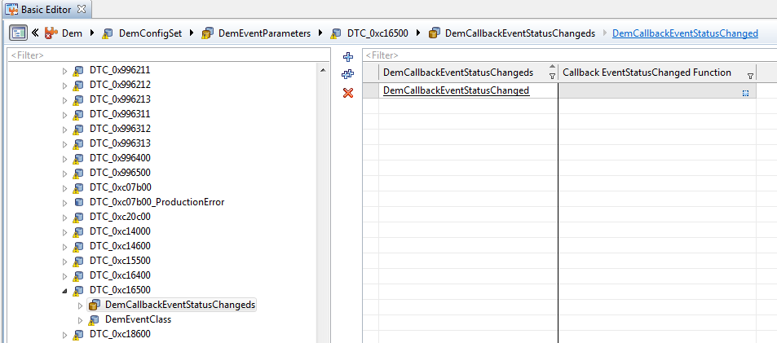
7. 同步保存工程.
8. 点击“DemEventClass” 菜单:  
     
   EnableCondition Group Ref = (Select the appropriate conditions for your particular DTC)  
     
   Event FailureCycle Ref = /ActiveEcuC/Dem/DemGeneral/IgnitionCycle  
     
   Event Priority = 1
9. 展开 Dem/DemConfigSet/DemEventParameters/DTC_0xcXXXXX/DemEventClass/DemDebounceAlgorithmClass/DemDebounceCounterBased 菜单. Click on the node.
10. 设置如下参数:  
      
    Debounce Behavior = DEM_DEBOUNCE_FREEZE  
    DebounceCounter Decrement Step Size = 128  
    DebounceCounter Failed Threshold = 127  
    DebounceCounter Increment Step Size = 127  
    DebounceCounter Passed Threshold = -128
11. 关闭Dem节点.

### Configurator: 配置SUM_ERRH

1. 展开 SwcSumGm/ERRH/ERRH_DTC_Triggered_Message/ERRH_Additional_DTCs node.
2. 点击加号按钮，在列表中添加新的DTC.
3. 同步保存工程.
4. 关闭DaVinci Configurator.

### Developer: 配置SWC_DTC_Handling

1. 在DaVinci Developer中打开工程.
2. 在Object Browser中, 打开Application Component Types/SWC_DTC_Handling菜单.
3. 打开Port Prototype List ，选择 Service Ports.
4. 点击New按钮，选择from Port Interface.
5. 选择DiagnosticMonitor port interface.  
     
   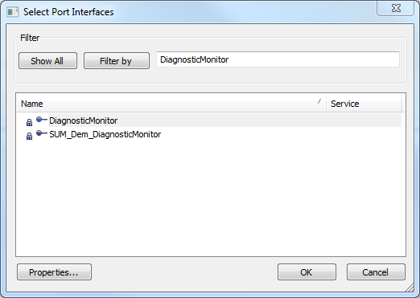
6. 改变port名字，make sure that the direction is Client.  
     
   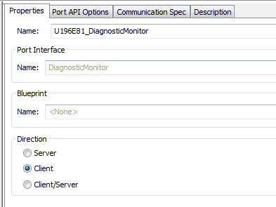
7. 打开Runnable Entity list ，选择Diagnostic_TroubleCode_Monitor_500ms这个runnable.  
     
   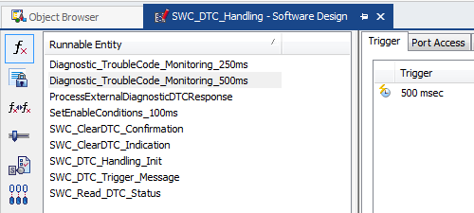
8. 打开Port Access选项.
9. 点击New按钮，选择Invoke Operations.
10. 给DTC找到Client Port Prototype. 选择 “SetEventStatus” 操作原型. 超时单元设置成sec.  
      
    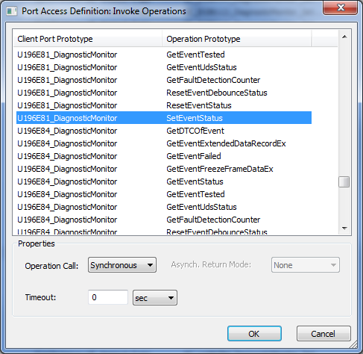
11. 再选择这个SWC_Read_DTC_Status runnable.
12. 打开Port Access菜单.
13. 点击New 按钮，选择Invoke Operations.
14. Search for the Client Port Prototype for the DTC. Select the “GetEventStatus” operation prototype. Also change the Timeout unit to sec.  
      
    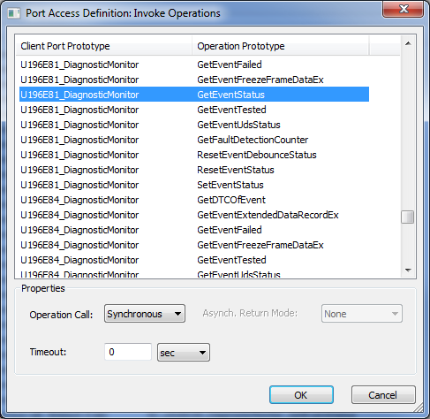
15. 保存工程.
16. 关闭SWC_DTC_Handling component.

### Developer: 配置DEM_SUMS_Adapter

1. 在Object Browser, 打开Application Component Types/DEM_SUMS_Adapter选项.
2. 打开Port Prototype list.
3. 打开Service Ports 选项.
4. 点击 New按钮，选择From Port Interface.
5. 选择CallbackEventUdsStatusChanged port interface.  
     
   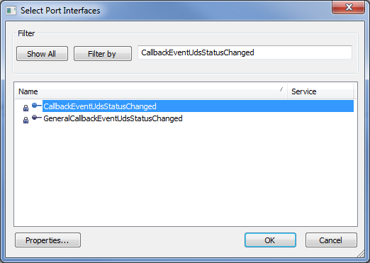
6. 把port的名字改成 “CBEventUdsStatusChanged_DTC_0xXXXXXX_DemCallbackEventStatusChanged”，change the direction to Server.  
     
   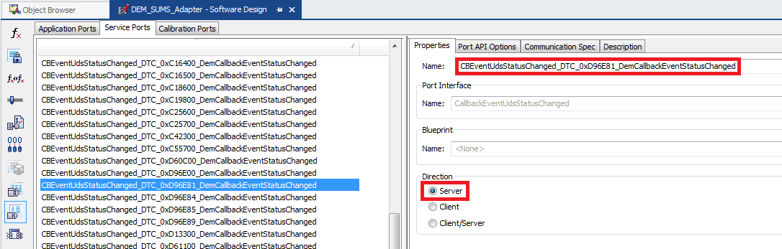
7. 点击New按钮，and select From Port Interface.
8. 选择SUM_Dem_CallbackEventStatusChange port interface.  
     
   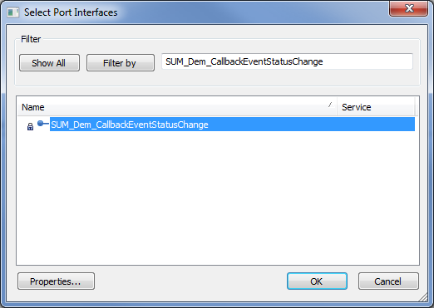
9. 名字改成“DEM_CBStatusEvt_DTC_0xXXXXXX” and the direction to Client.  
     
     
   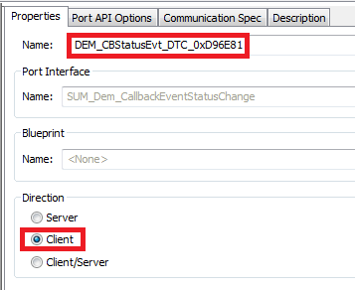
10. 打开Runnable Entity List.
11. 点击New 按钮，选择Server Runnables.
12. 选择你刚加的server port ， 保持prefix and postfix 是空的.  
      
    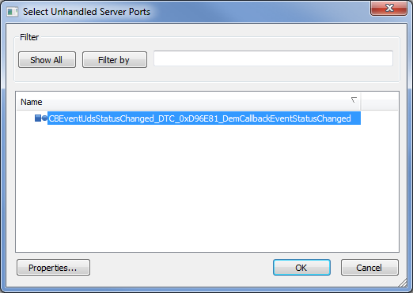
13. 点击new Runnable Entity ，打开Port Access 菜单.
14. 点击New 按钮，select Invoke Operations.
15. 选择DEM_CBStatusEvt_DTC_0xXXXXXX client port prototype， with Operation Type = EventStatusChanged. Timeout选成sec.  
      
    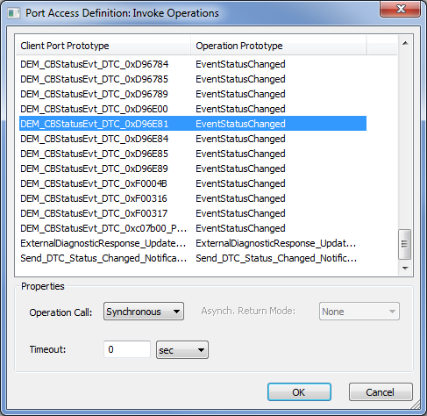
16. 保存工程and 关闭 DaVinci Developer.

### Configurator: Connecting the Components

1. 在DaVinci Configurator中打开工程.
2. 如果必要, 同步并保存工程.
3. 打开Runtime System ，选择ECU Software Components.
4. 打开Service Components/DemMaster_0 选项.
5. 选择Service Ports.
6. 连接CBEventUdsStatusChanged_DTC_0xXXXXXX_DemCallbackEventStatusChanged port 到DEM_SUMS_Adapter.  
     
   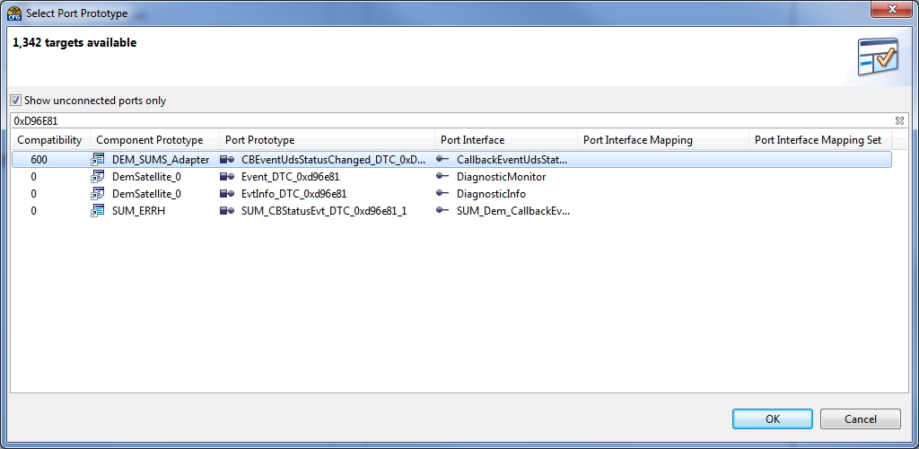
7. 打开DemSatellite_0 选项.
8. 点击Service Ports 选项.
9. Connect the Event_DTC_0xXXXXXX port prototype to the associated DiagnosticMonitor port on SWC_DTC_Handling.  
     
   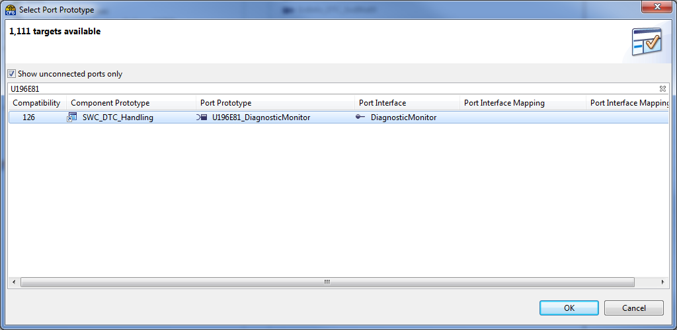
10. 在ECU Software Components里面, 打开 the Application Components/SUM_ERRH 模块.
11. 点击 the Service Ports 选项.
12. Connect the SUM_CBStatusEvt_DTC_0xXXXXXX_1 port to the associated port on DEM_SUMS_Adapter.  
      
    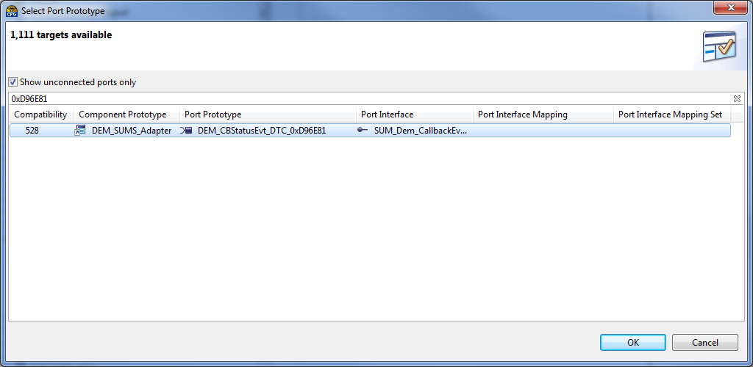
13. 保存工程.

### Configurator: 生成代码

1. 生成SwcSumGm, Dem, Rte这三个.
2. 生成Template File 给DEM_SUMS_Adapter 和SWC_DTC_Handling.
3. 保存工程，close DaVinci Configurator.

## 手改代码

1. If required, open \Appl\Source\DTC\dtc_list.h and add a DTC_DEF entry under the “Manual Entries” section at the bottom of the file. You will only need to do this if the DTC does not have a corresponding DTC_MASK calibration defined in the CalDef database. If you do need to add a DTC_DEF entry to the bottom of the file, just use the next available number for the statusBitPosition.
2. Edit \Appl\Source\SWC_DTC_Handling.c. Add a case statement for the new DTC to the switch block in the SWC_Read_DTC_Status() function.
3. In \Appl\Source\SWC_DTC_Handling.c, edit the MonitorExtDtcStatus function. Add the new DTC to the switch statement.
4. In \Appl\Source\SWC_DTC_Handling.c, edit the SwcWriteDtcStatus function. Add the new DTC to the switch statement.
5. Edit \Appl\Source\DEM_SUMS_Adapter.c. Fill in the logic for the CBEventUdsStatusChanged_DTC_0xXXXXXX_DemCallbackEventStatusChanged_CallbackEventUdsStatusChanged runnable. It should be similar to the runnables for other DTCs.